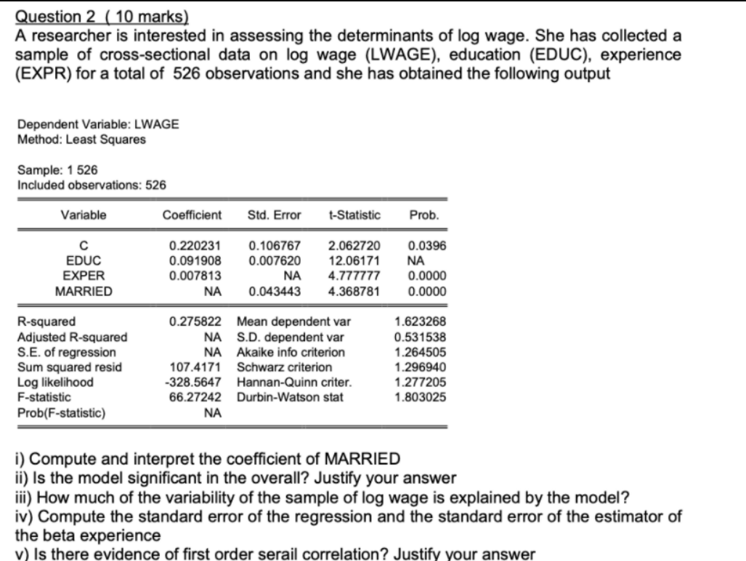

(i) MARRIED Coefficient = Std. Error x t-statistic

= 0.043443 x 4.368781

= 0.189792953

Interpretation: The slope of MARRIED = +0.19, which implies that if one person married, then on an average change in wage increases by 0.19%.

(ii) F-statistic is 66.27242 with degree of freedom is 3,523. Therefore, the significance F value is 0.000 which implies that the overall model is statistically significant. Because it is less than the level of significance. Hence, Prob (F-statistic) = 0.000

(iii) About 28% of the variation in the wages can be explained by the variation in the explanatory variables . About 72% of the variation is unexplained and is due to chance or other variables.

(iv) Calculation

* S.E. of the regression = SQRT(1- Adjusted R-squared)*(S.D. of Dependent var)

= SQRT(1- 0.27444)*( 0.531538)

= 0.452763063

* Adjusted R-squared = 1 - ((n-1)/(n-2)) x (1 - R-squared) =

= 1-((526-1)/(526-2))*(1-0.275822)

= 0.27444

* Std. Error (EXPER) = 0.007813/4.777777 = 0.001635279

(v) Durbin-Watson stat (DW) = 1.803025

The Durbin Watson statistic is a test for autocorrelation in a regression model's output. The DW statistic ranges from zero to four, with a value of 2.0 indicating zero autocorrelation. Values below 2.0 mean there is positive autocorrelation and above 2.0 indicates negative autocorrelation. Hence, the value is 1.8 which indicates that there is a **positive autocorrelation.**